**EXPENSE TRACKER SYSTEM**

END TERM REPORT

***by***

**Mayank Kaushal, Hirakjyoti Hira, Harshit Shankhdhar**

(Section: K18PA)

(Roll Number(s): 20, 21, 22)



**Department of Intelligent Systems**

**School of Computer Science Engineering**

**Lovely Professional University, Jalandhar**

04-2020

**Student Declaration**

This is to declare that this report has been written by me/us. No part of the report is copied from other sources. All information included from other sources have been duly acknowledged. I/We aver that if any part of the report is found to be copied, I/we are shall take full responsibility for it.

Harshit Shankhdhar

Roll number: 22

HirakJyoti Hira

Roll number: 21

Mayank Kaushal

Roll number: 20

Place: Lovely Professional University

Date: 05-04-2020

**BONAFIDE CERTIFICATE**

Certified that this project report “……….EXPENSE TRACKER SYSTEM……………..” is the bonafide work of “ Harshit Shankhdhar, Hirakjyoti Hira, Mayank Kaushal” who carried out the project work under my supervision.

Signature of the Supervisor

Miss Jasleen Kaur

ID of Supervisor: 25340

Department of Intelligent Systems

**TABLE OF CONTENTS**

**TITLE PAGE NO**

1. **Background and objectives of project assigned………………………1**
   1. **Problem Definition…...…………………………………………..…1**
   2. **Objectives…………………………………………………………...1**
   3. **Scope and Limitations…………………………………………..….1**
      1. **Scope………………………………………………………..…1**
      2. **Limitations…………………………………………………....1**
      3. **Outcome Of the Project………………………………..…….2**
2. **Description…………………………………………………………..…..2**
   1. **Project Description……………………………………………….....2**
   2. **Concept Used……………………………………………………..…3**
   3. **Hardware and Software Used……………………………………...3**
   4. **Description of Work Division in terms of Roles among Students...3**
   5. **Implementation of Scheduled work of Project………………….…3**
   6. **Screenshots……………………………………………………………4**

**1. Background and objectives of project assigned**

**1.1 Problem Definition**

The expense problem is faced by each and every person in this world. As they cannot remember where they spent money at the end of the month. When a particular person calculates where he spend money it may true that error can come in their calculations. These calculation leads to loss of money.

**1.2 Objectives**

The objectives of this system are:-

1. To keep track of daily expenses
2. To save money for pre-defined expenses which will help planning on your future investments

**1.3 Scope and Limitations**

**1.3.1 Scope**

This application helps anyone who are willing to manage their expenses like- house-wife, universities, industries etc….

It helps the user to save the money for future investments.

This application is not focused on any gender or any profession. Each and every person can use this application.

**1.3.2 Limitations**

1. Each entry is manual
   * 1. **Outcome of this Project**

It helped us to build up our knowledge in python using tkinter library.

With the help of this project we came to provide that system which is required by each and every person of this world to save money.

Each person wants to save money. This system is very useful in that particular case.

**2. Description**

**2.1 Description of the Project**

Expense tracker is a system which allows user to efficiently manage his/her expenses. Once we start off by tracking our expenses of each day, we will able to get better idea where you are spending your money. Tracking expenses daily can really help to us save lot of money.

**In this project**, we have used tkinter library of python for better clearance and understanding of the program. We have made three modules named **expense, date wise view, date range wise view**

**In Expense Module,** we have given date, title and expenses as user input. It will show the list of items user buying on that particular date which user put. Click on **ADD** button to add the information. Then it will show us in the form of list

**In Date Wise View Module,** we have given date and title as a user input. This module is used to find the particular item on given date. Click on **View** to see the details and click on **Clear** if you want to clear the details of the item.

**In Date Range Wise View Module,** we have given from date, to date, title as user input. This module help the user to search the particular item in a particular range of date i.e from date – to date which we take as user input. Click on **View** button to show the result and click on the **Clear** button to clear the details.

It will show result in form of date, title, expenses.

After all your work click on **Exit** button to close the program

* 1. **Concept Used**

1. Python programming
2. SQL
   1. **Hardware and Software used**
3. A suitable OS such as Windows
4. A laptop
5. Python3
6. Libraries:- Tkinter
   1. **Description of Work Division in terms of Roles among Students**

**Harshit Shankhdhar –** 3rd module Date Range wise view, Report File

**Mayank Kaushal –** 2nd module Date wise view

**Hirakjyoti –** 1st module Expense

* 1. **Implementation of scheduled work of Project**

Started this project on **9 march 2020**, we discussed on this project like – What we can do? How we can build it?

Later Hirakjyoti Hira started coding on **March 12**, building our 1st module. It take 1 day for completion of first module.

**On 16 march**, Mayank Kaushal started 2nd module. It takes 2.5 days for completion.

**On 24 march**, Harshit Shankhdhar started 3rd module. It takes the maximum days. Third one is difficult among three. So, it takes around four days for completion.

* 1. **Screenshots**

**View of 1st module**

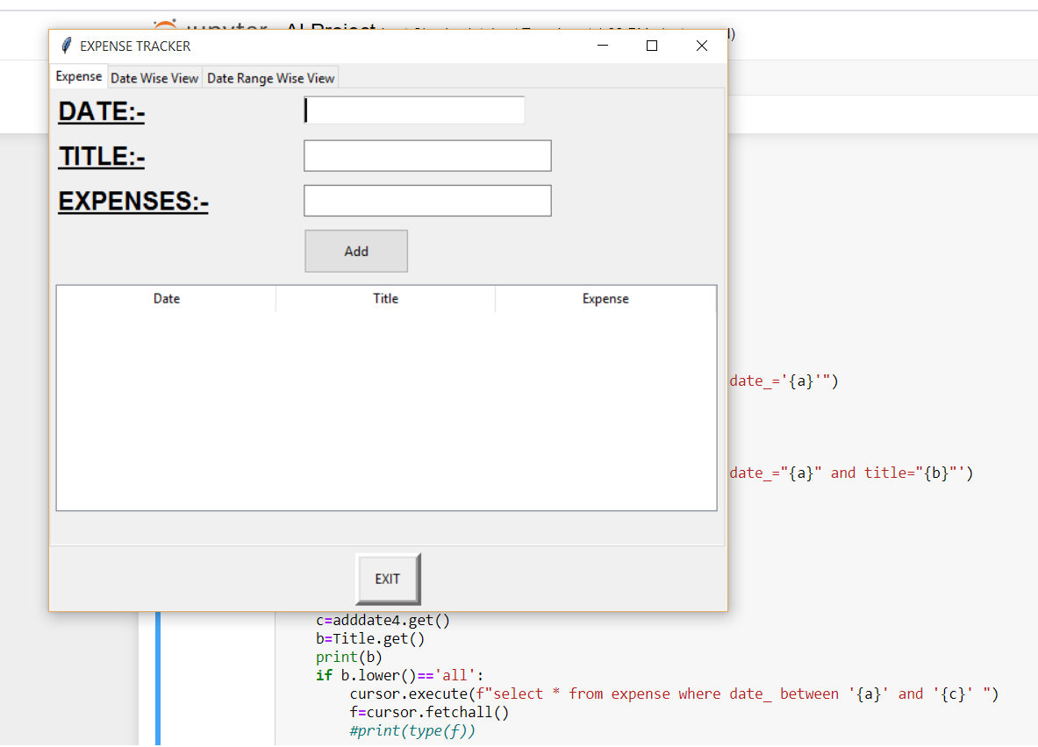

**View of 2nd module**

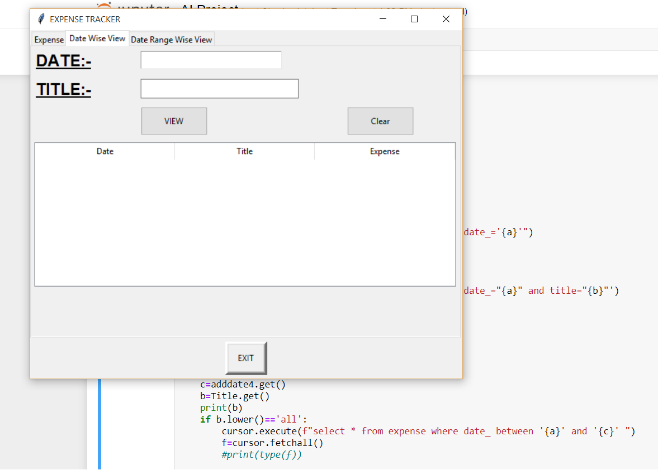

**View of 3rd module**

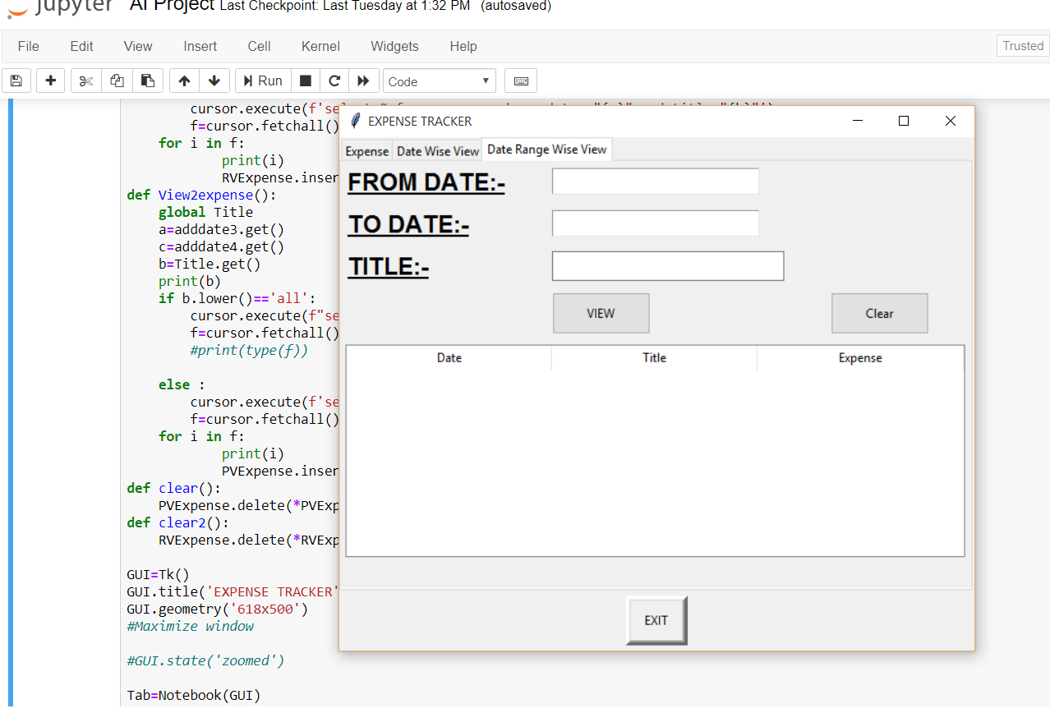

**1st module Example**

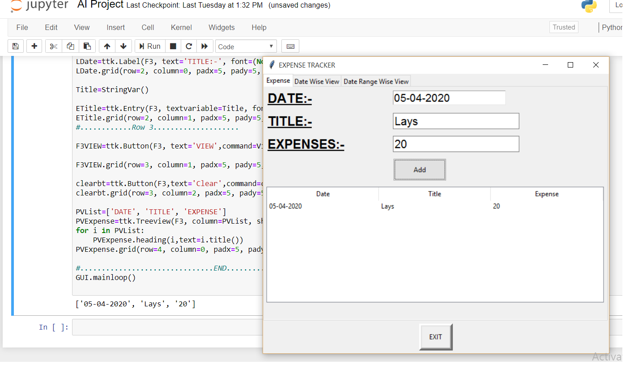

**1st module Example**

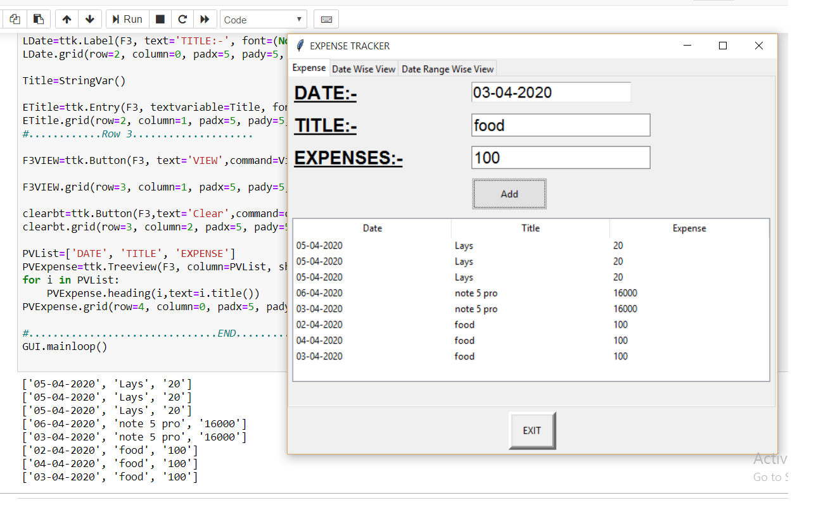

**2nd module Example**

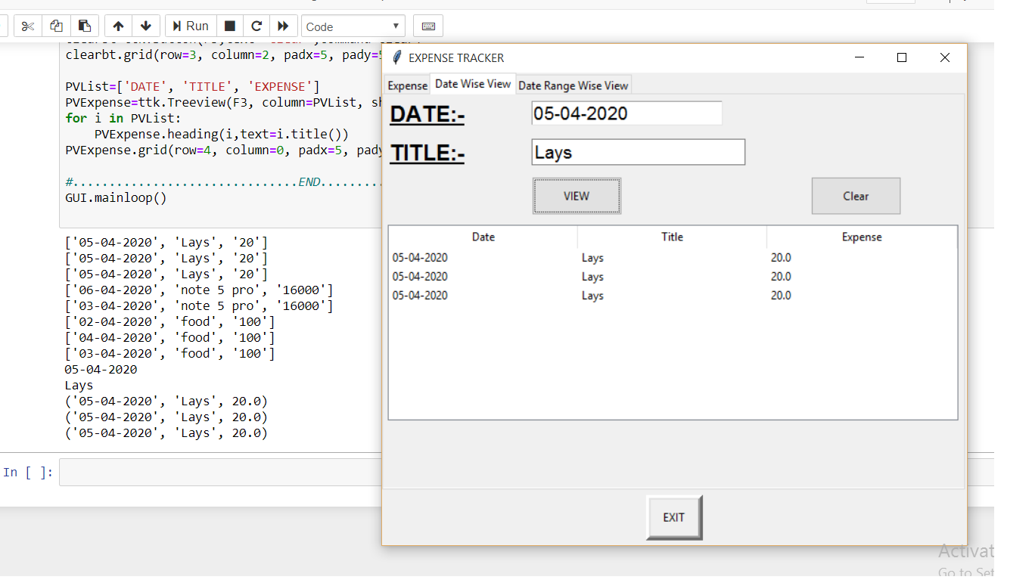

**3rd module Example**

